1. What did Einstein figure out about the nature of light from the Photoelectric Effect?
2. What is a photon?
3. What is the relationship between frequency and energy? What is the relationship between wavelength and energy?
4. Compare the two frequencies of light 4.2 x 1014 s-1 and 6.7 x 1019 s-1. Which would have the highest energy? Explain how you know.
5. Would microwave or radio waves have higher energy? Explain how you know.
6. What color of light has the most energy? What color of light has the lowest energy?
7. Describe both parts of how an atomic emission spectrum lines are formed. (Can use the end of your 2.2 notes to help you)
8. When is a photon emitted from an atom?
9. What causes an electron to get promoted to an excited energy state?
10. Why is it not possible for an electron to get excited halfway between energy levels?
11. What did Louis de Broglie say about electrons?
12. What is the Heisenberg Uncertainty Principle?
13. Describe the current model of the atom.
14. What is an orbital? What are the types of orbital?
15. What is the difference between orbits and orbitals?

**Use the diagrams below to answer the following questions:**

e

a

b

c

d

f

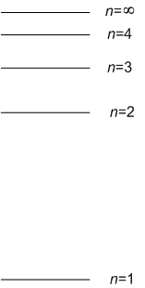

*n=4*

e

c

f

d

b

a

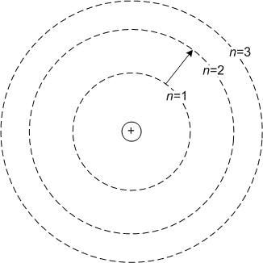

1. Using the diagram, list all of the transitions (a, b, c, d, e or f) would result in light being given off (emitted)? Explain your reasoning.
2. Using the diagram, list all of the transitions (a, b, c, d, e or f) would result in energy being absorbed? Explain your reasoning.
3. Using the diagram, list all of the transitions (a, b, c, d, e or f) where to electrons are moving to a more excited state? How do you know?
4. Using the diagram, list all of the transitions (a, b, c, d, e or f) are electrons returning to their ground states (lowest possible level)? How do you know?
5. If green light is emitted when transition d occurs, what colors of light could possibly be emitted during transition e?