- Describe VSEPR.

- Using VSEPR explain why a molecule would take on a bent shape instead of a linear shape.

- Answer the following questions using the picture below.
A B C D
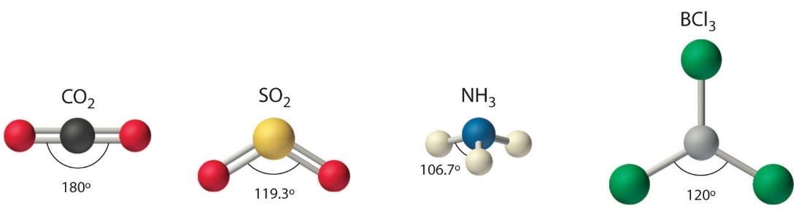
  - Which molecule(s) have no lone pairs on the central atom?

  - Which molecule is trigonal planar?

- What type of shape consists of 2 atoms bonded to the central atom with 2 lone pairs?

- Fill in the following chart
Molecule | Lewis Structure | Molecular geometry (Shape)
SiCl₄
(Cl is chlorine)

CO₃²⁻

SCl₂
(Cl is chlorine)

Molecule | Lewis Structure | Molecular geometry (Shape)
CO₂

CO |  | Hint: What is the only shape it could look like?
H₂Se
SeO₃
H₃O⁺
PBr₅
RnF₄
TeF₆

