Directions: Answer the following questions. SHOW WORK for all calculations to RECEIVE CREDIT.
- What is a half-life?

- If we start with 400 atoms, how many atoms would remain after one half-life? ________ After two half-lives? ________ After three half-lives? ________ After four half-lives? ________

- If the half-life of iodine-131 is 8.10 days, how long will it take a 50.00 g sample to decay to 6.25 g?

- The half-life of hafnium-156 is 0.025 s. How long will it take a 560 g sample to decay to one-fourth its original mass? (Hint: if you started with one how many times do you need to divide by 2 to get ¼?)

- If it takes a 542 g sample of cobalt-60 26.35 y to decay to 16.9 g how long is the half-life of cobalt -60?

- If it takes 49.3 y for a 688 g sample of tritium to decay to 43.0 g how long is the half-life of tritium?

Use the following graph of the decay of Strontium-90 to answer the following questions:
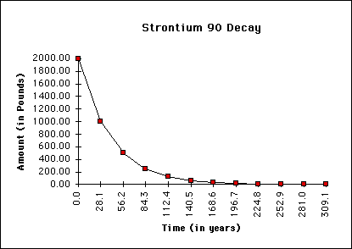
- How long is a half-life for Sr-90?

- If only 600 lbs of the Sr-90 remains, how many years have passed?

- How much would remain after 3 half-lives?

- A sample originally contained 100 grams of Sr-90. How many grams of Sr-90 would remain after 112.4 years?

Use the following chart to answer the following questions:
Radioactive Substance | Approximate half-life
Radon-222 | 4 days
Iodine-131 | 8 days
Radium-226 | 1600 years
Plutonium-239 | 24,120 years
Uranium-238 | 4,470,000,000 years

- If we start with 8000 grams of radium-226, how much would remain after 3,200 years?

- If we start with 20 grams of plutonium-239, how many grams would remain after 72,360 years?

- How many years would have to pass for 400 grams sample of Uranium-238 to decay to 12.5% of the original mass? (Hint: you are starting with 100%)

- How much time would it take for a 500 gram sample of Iodine-131 to decay to 31.25 grams? How many half-lives is that?

