Directions: Answer the following questions. SHOW WORK for all calculations
- What is a half-life?
How long it takes for the half of the sample to decay

- If we start with 400 atoms of a radioactive substance, how many atoms would remain after one half-life? __200 atoms_______
After two half-lives? 100 atoms after three half-lives? 50 atoms; after four half-lives? 25 atoms

- If the half-life of iodine-131 is 8.10 days, how long will it take a 50.00 g sample to decay to 6.25 g?

50.0 g/2/2/2 = 6.25 g 3 half-lives 8.10 g x 3 h.l. = 24.3 days

- The half-life of hafnium-156 is 0.025 s. How long will it take a 560 g sample to decay to one-fourth its original mass? (Hint: if you started with one how many times do you need to divide by 2 to get ¼?)

1/2/2 = .25 2 h.l. 2 h.l. x .025 s = .050 s

- If it takes a 542 g sample of cobalt-60 26.35 y to decay to 16.9 g how long is the half-life of cobalt -60?

542 g/2/2/2/2/2 = 16.9 g 5 h.l. 26.35/5 h.l, = 5.27 y

- If it takes 49.3 y for a 688 g sample of tritium to decay to 43.0 g how long is the half-life of tritium?

688 g/2/2/2/2 = 43.0 g 4 h.l. 49.3 y/4 h.l. = 12.3 y

Use the following graph of the decay of Strontium-90 to answer the following questions:
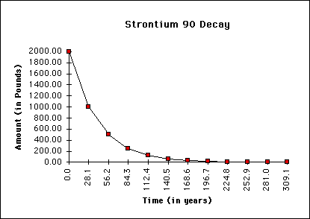
- How long is a half-life for Sr-90?

28.1 y
- If only 600 lbs of the Sr-90 remains, how many years have passed?
53 y
- How much would remain after 3 half-lives?
250 g

- A sample originally contained 100 grams of Sr-90. How many grams of Sr-90 would remain after 112.4 years?
112.4/28.1 = 4 h.l. 100g/2/2/2/2 = 6.25 g
Use the following chart to answer the following questions:
Radioactive Substance | Approximate half-life
Radon-222 | 4 days
Iodine-131 | 8 days
Radium-226 | 1600 years
Plutonium-239 | 24,120 years
Uranium-238 | 4,470,000,000 years

- If we start with 8000 grams of radium-226, how much would remain after 3,200 years?
3200 y/1600 = 2 h.l. 8000/2/2 = 2000 g

- If we start with 20 grams of plutonium-239, how many grams would remain after 72,360 years?
72360 y/24120 = 3 h.l. 20.2g/2/2/2 = 2.50 g

- How many years would have to pass for 400 grams sample of Uranium-238 to decay to 12.5% of the original mass? (Hint: you are starting with 100%)

100/2/2/2 = 12.5% 4,470,000,000 years x 3 h.l. = 13,410,000,000 y

- How much time would it take for a 500 gram sample of Iodine-131 to decay to 31.25 grams? How many half-lives is that?

500 g/2/2/2/2 = 31.25 g 4 h.l. 4 h.l. x 8 days = 32 days

