Name:
Date:
Period: Introduction to Molecular Polarity

Go to the website listed below. Click the play symbol on the simulation.
https://phet.colorado.edu/en/simulation/molecule-polarity
Part 1: Two Atom Investigation
- Select the two atom simulation. Keep the box for bond dipole checked and check the boxes to show the partial charges and the bond character
- Set the electronegativity of A at less. Then increase and decrease the electronegativity of atom B. Observe the arrow, partial charge and bond character.
- Fill in the following observation about what happens as the electronegativity of atom B increases.
- Describe how the arrow changes

- Describe how the partial charges change

- Describe how the bond character changes

- Now put the electronegativity for A to the middle and vary the electronegativity of B and observe the results.
Fill in the following information.
- The polarity arrow always points to the ___________________________ electronegative atom.
- The partial positive charge is always on the ___________________________ electronegative atom.
- The larger the electronegativity difference the more ___________________________ bond character.
Part 2: Three Atom Investigation
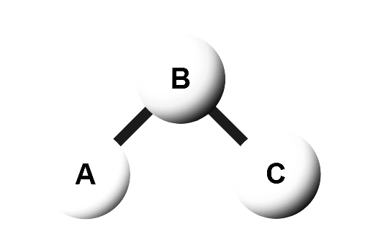
- Keep the original “bent” arrangement of atoms and set the electronegativities of A and C to less and B to middle. Click to show the bond dipoles, molecular dipoles and partial charges.
  - Draw the bond dipoles on the bonds on the diagram
  - In a different color show the overall molecular dipole in the diagram
  - Draw the partial charge symbols in another color in the diagram.
  - Click the electric field on. Describe what happened to the molecule - be very specific.
- Click the reset button. Keep the “bent” arrangement of atoms and set the electronegativities of A and C to more and B to middle. Click to show the bond dipoles, molecular dipoles and partial charges.
  - Draw the bond dipoles on the bonds on the diagram
  - In a different color show the overall molecular dipole in the diagram
  - Draw the partial charge symbols in another color in the diagram.
  - Click the electric field on. Describe what happened to the molecule - be very specific.

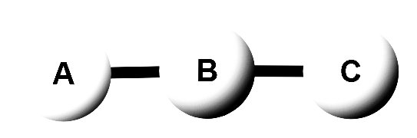
- Click the reset button. Change the arrangement of atoms to a “linear” arrangement by dragging A and C to match the diagram and set the electronegativities of A and C to more and keep B to middle. Click to show the bond dipoles, molecular dipoles and partial charges.
  - Draw the bond dipoles on the bonds on the diagram
  - In a different color show the overall molecular dipole in the diagram
  - Draw the partial charge symbols in another color in the diagram.
  - Click the electric field on. Describe what happened to the molecule - be very specific. (if it is not completely straight it will affect the results)

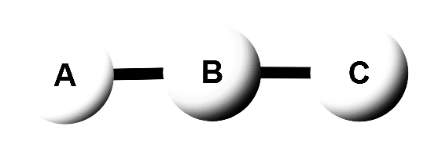
- Click the reset button. Rotate the molecule to keep the “linear” arrangement (see below) and set the electronegativities of A to more, keep B to middle, and set C to less. Click to show the bond dipoles, molecular dipoles and partial charges.
  - Draw the bond dipoles on the bonds on the diagram
  - In a different color show the overall molecular dipole in the diagram
  - Draw the partial charge symbols in another color in the diagram.
  - Click the electric field on. Describe what happened to the molecule - be very specific.

- Click the reset button. Rotate the molecule to keep the “linear” arrangement (see below) and set the electronegativities of A and C to less and keep B to middle. Click to show the bond dipoles, molecular dipoles and partial charges.
  - Draw the bond dipoles on the bonds on the diagram
  - In a different color show the overall molecular dipole in the diagram
  - Draw the partial charge symbols in another color in the diagram.
  - Click the electric field on. Describe what happened to the molecule - be very specific. (if it is not completely straight it will affect the results)

- Click the reset button. Rotate the molecule to keep the “linear” arrangement (see below) and set the electronegativities of A, Band C to middle. Click to show the bond dipoles, molecular dipoles and partial charges.
  - Draw the bond dipoles on the bonds on the diagram
  - In a different color show the overall molecular dipole in the diagram
  - Draw the partial charge symbols in another color in the diagram.
  - Click the electric field on. Describe what happened to the molecule - be very specific.

Summary
Summarize what you learned by answering the following questions.
- How do you know what way to point the polarity arrows?
- Can a molecule have bond dipoles/arrows but not have a molecular dipole? Explain.
- What happens when a molecule with a dipole is put in an electric field? Be specific.

Part 3: Real Examples
You will now apply what you learned to real molecules. The real molecules does not work on the simulation so apply what you know and use your electronegativity chart to help you.

HF - The ball and stick structure for HF is shown. Answer the following and do what is asked
- Which atom is more electronegative? _______________
- Draw a bond polarity arrow (bond dipole) or draw the partial charges on the molecule
- Would you expect this to move in an electric field? Draw it in the field provided.
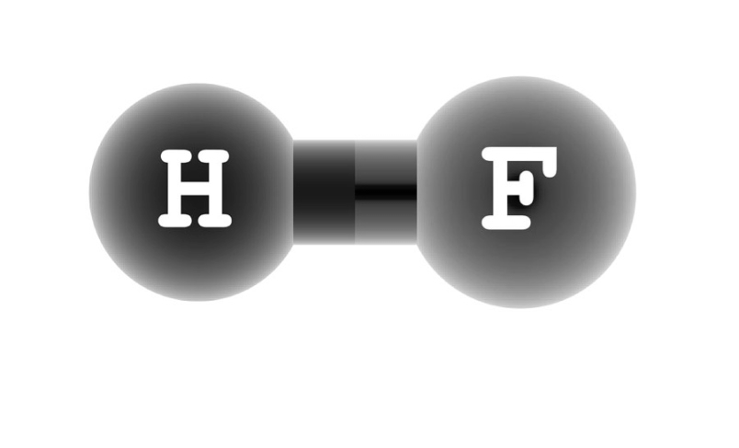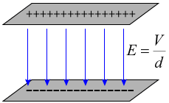

H₂O - The ball and stick structure for H₂O is given. Answer the following and do what is asked.
- Which atom is more electronegative? _______________
- Draw a bond polarity arrow (bond dipole) or draw the partial charges on the molecule
- If there is a molecular dipole draw it.
- Would you expect this to move in an electric field? Draw it in the field provided.
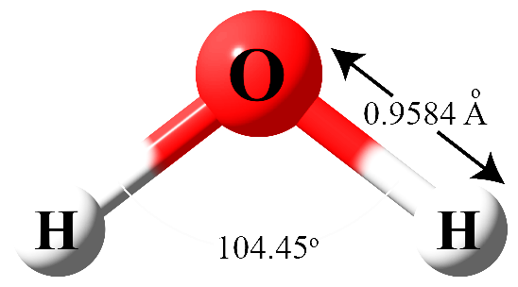

CO₂ - The ball and stick structure for CO₂ is given. Answer the following and do what is asked.
- Which atom is more electronegative? _______________
- Draw a bond polarity arrow (bond dipole) or draw the partial charges on the molecule
- If there is a molecular dipole draw it.
- Would you expect this to move in an electric field? Draw it in the field provided.

