Name:

Date:

Period:

Molecule Shapes

**MODEL 1:**

***Molecule Shapes* Simulation**

**(**[**http://phet.colorado.edu/en/simulation/molecule-shapes**](http://phet.colorado.edu/en/simulation/molecule-shapes)**)**

PART I: ELECTRON DOMAINS

1. Explore the *Model* screen of the simulation. As you explore, answer the following questions.
   1. How does adding an **atom** affect the position of existing atoms or lone pairs?
   2. How does adding a **lone pair** affect the position of existing atoms and lone pairs?
2. Is the effect of adding bonded **atoms** and **lone pairs** to the central atom similar? Explain why this could be the case.

We can think of a bond or a lone pair of electrons as a “domain” of electrons. Single bonds, double bonds, and triple bonds each count as one domain.

1. How do the electrons in bonds (bonding domains) differ from lone pairs (non-bonding domains)?
2. Turn on **bond angle**. What happens to the bond angle when you add or remove an electron domain?
3. Can you force the atoms into new configurations by pushing atoms around? What does this suggest about the configuration of atoms in real molecules?
4. Turn on **molecule geometry** and see how it changes with the lone pairs and atoms. Write a definition for the term *Molecule Geometry*.
5. Create a shape with 2 atoms bonded and 1 lone pair. Does the molecular geometry change based on if it is a single or double bond? What are the two things that determine the molecular geometry?

PART 2: DRAWING MOLECULES TO SHOW 3-DIMENSIONALITY

**MODEL 2:**

**Line, Wedge and Dash Drawings**

Line: In the plane of the paper: **_____**

Wedge: Coming forward, in front of the plane of the paper: 

Dash: Going backward, behind the plane of the paper: 

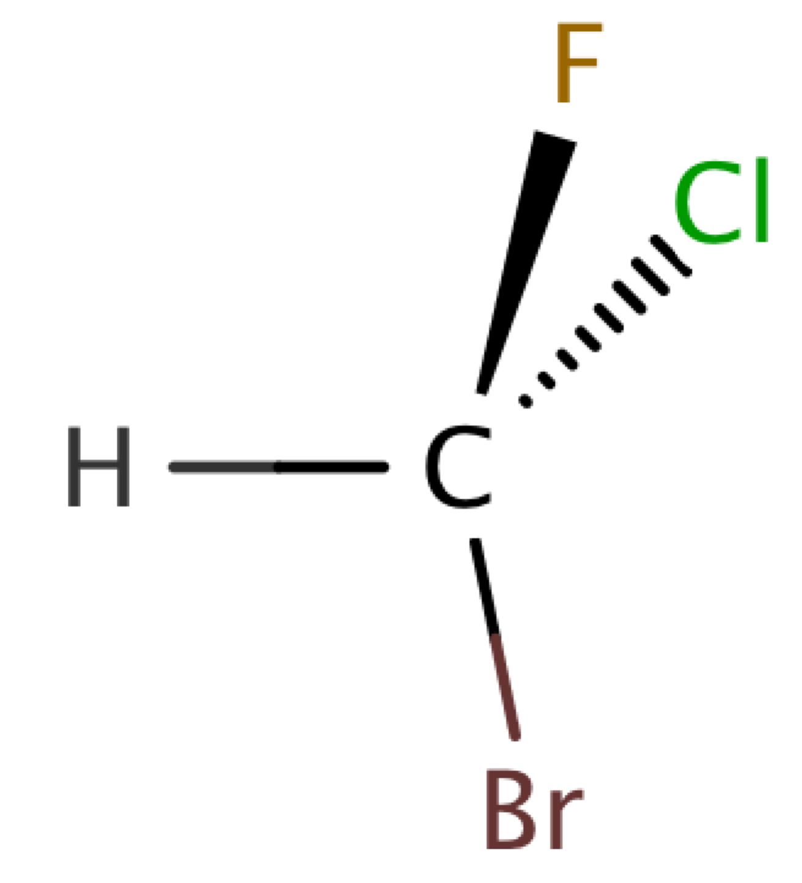

1. Where is each of the 5 atoms in the molecule CHFClBr?

In the plane of the paper ______ ______ ______

In front of the plane of the paper ______

Behind the plane of the paper ______

1. Using the *Model* screen, add bonding domains (●) to the central atom (○). Using lines, wedges and dashes from Model 2, draw each molecule’s shape. **Do not add lone pairs.**

|  |  |  |  |
| --- | --- | --- | --- |
| Bonding Domains Around Central Atom | Drawing of Shape | Molecular Geometry | Bond Angles |
| 2 | ● ─ ○ ─ ● | Linear | 180º |
| 3 | ○ |  |  |
| 4 | ○ |  |  |
| 5 | ○ |  |  |
| 6 | ○ |  |  |

1. In the *Model* screen, build a molecule with 5 atoms attached to the central atom. Look at the molecule geometry and electron geometry. **Predict** what will happen to the molecule geometry as you replace atoms with lone pairs.

Your Prediction:

Your Results:

1. For each of the following you will be replacing a bond with a lone pair to keep the total number of domains the same. Make a prediction. Then test your prediction with the simulation and draw the correct **molecule geometry** for each leaving the **grey boxes blank**.

|  |  |  |  |  |
| --- | --- | --- | --- | --- |
| Predict First, Then Compare with the Simulation | | | | |
| Number of Domains Around Central Atom | 1 Lone Pair | 2 Lone Pairs | 3 Lone Pairs | 4 Lone Pairs |
| 3 |  |  |  |  |
| 4 |  |  |  |  |
| 5 |  |  |  |  |
| 6 |  |  |  |  |

1. What two configurations gave you a bent shape? Compare the bond angles for the two versions. How does having a second lone pair affect the bond angle? Why do think that is?

PART 3: COMPARING MODEL VS. REAL MOLECULES

1. Explore the *Real Molecules* screen.
2. List the molecules that show a **difference in bond angle** between “Real” and “Model”. Note: differences in bond angle may be small.

|  |  |
| --- | --- |
| Molecule | Number of Lone Pair Domains |
|  |  |
|  |  |
|  |  |
|  |  |
|  |  |

1. What do all of the molecules in the table have in common?
2. What trend do you observe that distinguishes lone pairs from bonding domains?

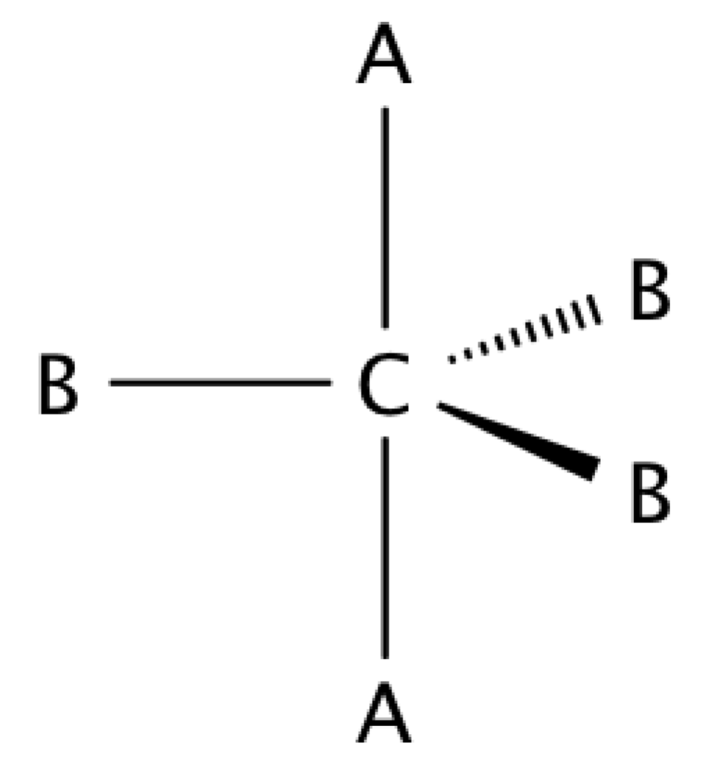

1. Use the simulation to build a system with 5 bonds. This is called a trigonal bipyramidal structure. The two different sites in a trigonal bipyramid are labeled as A and B in the drawing to the right.

1. Each A atom is adjacent to 3 B atoms. What is the A-C-B bond angle?
2. Each B atom is adjacent to 2 A atoms and 2 B atoms. What is the B-C-B bond angle?
3. In a system with 4 atoms and 1 lone pair, predict whether the lone pair will be in a B site or an A site? Explain.
4. Select the molecule SF4 in the Real Molecules screen to check your prediction from question c. Which interactions are more important in determining where the lone pair will go?

**EXERCISES**:

1. A molecule has 2 double bonds on the central atom and no lone pairs. Predict the molecule geometry. What do you think the bond angles would be?
2. For each of the molecules below, determine the molecule geometry and bond angles. **Draw** pictures to show your geometries.
   1. HCl (1H and 1 Cl)

Molecule geometry:

Bond angle:

* 1. CCl4 (4 Cl atoms, no lone pairs on C)

Molecule geometry:

Bond angle:

* 1. PF3 (3 F atoms, 1 lone pair on P)

Molecule geometry:

Bond angle:

* 1. OF2 (2 F atoms, 2 lone pairs on O)

Molecule geometry:

Bond angle:

* 1. I3- (2 I atoms and 3 lone pairs on central I)

Molecule geometry:

Bond angle: