Directions: Answer the following questions. SHOW WORK ON HALF LIFE TO GET CREDIT. Standard 1:
- Define the atom.

- Find protons, neutrons, electrons, and mass number for francium-224.

- Fill in the following chart:
Subatomic Particle | Relative Charge | Location in Atom | Relative Mass (amu)
Proton
Neutron
Electron
- Fill in the following chart:
Element Shorthand (^{A}X) | Atomic # | Protons | Neutrons | Electrons | Mass #
⁵⁹Co
 |  | 16 | 17
 | 18 |  |  |  | 39
Standard 2:
- What is the most common isotope of Sr out of ⁸⁴Sr, ⁸⁶Sr, ⁸⁷Sr, ⁸⁸Sr? What property makes them isotopes of the same element? What is different about the isotopes?

Standard 3:
- Fill in the following chart for the three types of decay.
 | Symbol | Mass | Charge | Penetration Power/Strength | What is the particle made of?
Alpha
Beta
Gamma

- What happens to mass number and atomic number for each of the 3 types of decay?

- What makes some elements radioactive and unstable? Make sure to include the following in your answer: electromagnetic force, strong nuclear force, protons, and neutrons.

- Define fusion and fission. Do chemical or nuclear reactions (fusion and fission) produce more energy?

- Cerium-150 has decayed from 7800 g to 122 g. If the half-life is 54 hours how long did it take to decay?

- After 679 years an 87.6 g sample has decayed to 11.0 g. How long is the half-life of the sample?

- 556 g sample has been decaying for 702 seconds. If the half-life is 176 seconds how much of the sample remains?

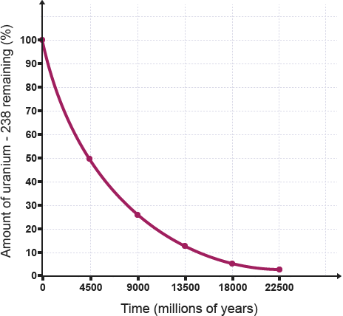
Use the following graph to the next three questions:

- What is the half-life of the isotope?

- How much remains after 4 half-lives?

- At what time is there 20% of the original isotope left

Standard 4:
- What process of formation have all elements except Hydrogen undergone? Where did elements until iron form? How and where did the elements past iron form? What is the trend in abundance of elements as atomic number increases? Why is that the trend?

Overarching Concepts:
- Draw a beryllium-10 atom and label the parts.

- What is happening inside ³²P atom as it decays into ²⁸Al? (Be specific about the type of decay and any changes to the subatomic particles.)

