Directions: Answer the following questions. SHOW WORK ON HALF LIFE TO GET CREDIT. Standard 1:
- Define the atom.
An atom is the smallest particle of an element that retains its identity in a chemical reaction.

- Find protons, neutrons, electrons, and mass number for francium-224.
p⁺ =87, n⁰ = 137, e⁻ = 87, mass number = 224
- Fill in the following chart:
Subatomic Particle | Relative Charge | Location in Atom | Relative Mass (amu)
Proton | 1+ | Nucleus | 1
Neutron | None | Nucleus | 1
Electron | 1- | Orbitals | 0
- Fill in the following chart:
Element Shorthand (^{A}X) | Atomic # | Protons | Neutrons | Electrons | Mass #
⁵⁹Co | 27 | 27 | 32 | 27 | 59
³³S | 16 | 16 | 17 | 16 | 33
³⁹Ar | 18 | 18 | 21 | 18 | 39
Standard 2:
- What is the most common isotope of Sr out of ⁸⁴Sr, ⁸⁶Sr, ⁸⁷Sr, ⁸⁸Sr? What property makes them isotopes of the same element? What is different about the isotopes? strontium-88 (I got the answer by rounding atomic mass to closest whole number); the same number of protons/same atomic number; different mass number and neutrons
Standard 3:
- Fill in the following chart for the three types of decay.
 | Symbol | Mass | Charge | Penetration Power/Strength | What is the particle made of?
Alpha | α or | Largest | Positive | Weakest | Helium nucleus
Beta | β or | Medium | Negative | Medium | Electron
Gamma | γ | No mass/smallest | Neutral | Strongest | High energy photon

- What happens to mass number and atomic number for each of the 3 types of decay?
Alpha: atomic # dec by 2 and mass # by 4
Beta: atomic # inc by 1 and mass # stay same
Gamma: atomic # and mass # stay same
- What makes some elements radioactive and unstable? Make sure to include the following in your answer: electromagnetic force, strong nuclear force, protons, and neutrons.
The electromagnetic force is greater than the strong nuclear force because of one of the following: too many p⁺, too many n⁰, or not enough

- Define fusion and fission. Do chemical or nuclear reactions (fusion and fission) produce more energy?
Fusion is combing two nuclei; fission is splitting of one nuclei: Nuclear
- Cerium-150 has decayed from 7800 g to 122 g. If the half-life is 54 hours how long did it take to decay?
7800 g/2/2/2/2/2/2 = 122 g 6 h.l. x 54 hours = 324 hours

- After 679 years an 87.6 g sample has decayed to 11.0 g. How long is the half-life of the sample?
87.6 g/2/2/2 = 11.0 g 3 h.l. 679 y/3 h.l. = 226 y

- 556 g sample has been decaying for 702 seconds. If the half-life is 176 seconds how much of the sample remains?
702 s/176 s = 4 h.l. 556 g/2/2/2/2 = 34.8 g
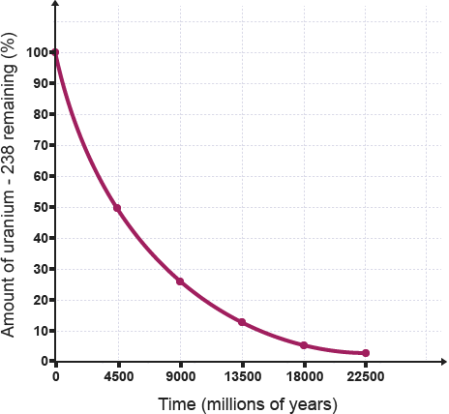
Use the following graph to the next three questions:

- What is the half-life of the isotope?
4500 million years

- How much remains after 4 half-lives?
6%

- At what time is there 20% of the original isotope left
11250 million years

Standard 4:
- What process of formation have all elements except Hydrogen undergone? Where did elements until iron form? How and where did the elements past iron form? What is the trend in abundance of elements as atomic number increases? Why is that the trend?
Fusion from a smaller element to a bigger one
Stars
Supernova of a star
As atomic number increases the abundance of elements tend to decrease because the elements are harder to form especially after iron as they require a supernova
Overarching Concepts:
- Draw a beryllium-10 atom and label the parts.
- What is happening inside ³²P atom as it decays into ²⁸Al? (Be specific about the type of decay and any changes to the subatomic particles.)
P is going through an alpha decay where 2 protons and 2 neutrons leave as a helium nucleus

