Directions: Answer the following questions.
Standard 1:
- What was Democritus atomic theory?
Atoms were indivisible, indestructible, and make up everything

- What was Dalton’s atomic theory?
All elements are composed of small indivisible particles called atoms
Atoms of the same element are identical. The atoms of one element are different from the atoms of any other element
Atoms of different elements can physically mix together or can chemically combine in simple whole-number ratios to form compounds.
During a chemical reaction the elements are neither changed, created, or destroyed
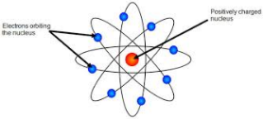
- What is Rutherford’s model? Describe his experiment
Positive nucleus in the center with electrons randomly orbiting around it and made of mostly empty space
Shot alpha particles through gold foil and expected them to go through with slight deflection, but instead they mostly went straight through or bounce back.

- What is Thomson’s model? Describe his experiment
Plum pudding model where there was a positive sphere with negative electrons spread throughout it.
Cathode ray tube experiment is where the cathode ray was deflected by a positive magnet because it was made of negative particles that were attracted to the magnet.
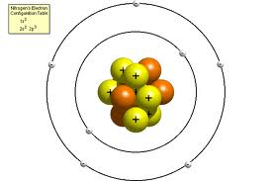
- What is the Bohr model of an atom?
Nucleus with electrons in fixed orbits at fixed energy levels around it
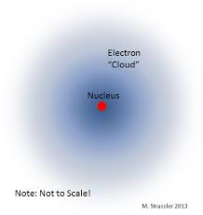
- What is the current model of the atom? Define the current model.
Quantum mechanical model
Electrons in orbitals (regions
- What order do the models go in? Why have atomic models changed over time?
Democritus, Dalton, Thomson/plum pudding, Rutherford, Bohr, and quantum; models changed as new information was discovered that showed the previous one was wrong
Standard 2:
- Define photon.
A B C D
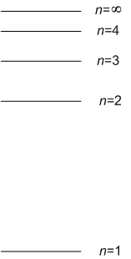
Quantum or fixed amount of energy

- Answer the following based off the picture to the right:
  - Which arrow(s) is absorbing energy?
A, B
  - Which arrow is releasing the most energy?
C
  - If arrow D is representing blue light what color could C involve?
Indigo or violet

Standard 3:
- What is the relationship between wavelength and frequency? Relationship between frequency and energy? What speed does all light travel at?
Inversely proportional/one increases the other decreases; directly proportional/one inc so does the other; 3.00 x 10⁸ m/

- Identify the type of radiation for the following:
  - A wavelength of 5.3 x 10⁻¹¹ m gamma rays
  - A frequency of 3.47 x10⁸ Hz radar
- Would radar or radio waves have more energy? Explain why.
Radar because it has a higher frequency

Standard 4:

- What is the evidence that light has particle properties?
Photoelectric effect where photons can cause an electron to be ejected
- Describe the full process that causes the different lines on an atomic spectrum or different colors in flame tests. Why do different elements have different spectrums?
Electrons absorbing energy to go to a higher energy level and then releasing energy as light as they go from higher to lower energy levels; different electron configurations

Standard 5:

- What is the difference between the Bohr and Quantum Mechanical Model?
Bohr Model: electrons on fixed orbits around the nucleus
Quantum mechanical model: electrons in orbitals around the nucleus
- What is the difference between orbits and orbitals?
Orbits are fixed path and orbitals are regions
- Write the 2 electron configurations for rhodium.
Standard: 1s²2s²2p⁶3s²3p⁶4s²3d¹⁰4p⁶5s²4d⁷
Noble Gas Notation: [Kr] 5s²4d⁷

Overarching Concepts and General Review:
- Compare and contrast the Rutherford and plum pudding models.
Same: both have electrons
Different: plum pudding has positive sphere electrons are in, but the Rutherford has its positive charge in nucleus with electrons randomly orbiting.

- Describe how electrons absorb and release energy in an atom.
Electrons absorb a quantum of energy to go to a higher energy level; Electron release a quantum of energy as they go from higher to lower energy levels

- Answer the following questions about light being absorbed/released for the diagram on the right.
  - Which arrow represents the highest energy being released? Explain how you know.
A B C D
B; going up the largest amount of energy based on energy levels

  - Which arrow represents the largest wavelength absorbed? Explain how you know.
A; going up by smallest amount of energy so it will have a lower frequency

  - Which arrow represents the largest frequency released? Explain how you know.
B; going up the largest amount of energy based on energy levels so would have
highest frequency

