Standard 1: The periodic table is systematically arranged into columns and rows of elements that have particular characteristics in common.
- What property is the periodic table arranged by? What are the rows and columns of the periodic table called?

- How many valence electrons does P have?

- What causes the elements in the same group to have the same properties?

- Which of the following would have the most similar properties: Ni, Zn, Hg, and Ga? Explain why.

- What are the names, locations, and properties for each of the five main element groups (ex: halogens)?

Standard 2: The periodic table is sectioned into 3 types of elements: metals, nonmetals and metalloids
- What are three types of elements? How can you tell what type an element is based off the periodic table? What properties does each type have?

- An element has the following properties: dull, brittle and a poor conductor of electricity. Would it be a metal, nonmetal, or metalloid?

- Identify the type of element for each of the following: W, Si, and N

Standard 3: The elements on the periodic table are arranged so that certain properties increase or decrease as you go across or down the periodic table.
- Describe all three periodic trends as they go across and down the periodic table.

- Oxygen has a high electronegativity and ionization energy. What does that mean in terms of atomic structure, attractions, and electrons?

- Which of the following elements would have the largest atomic radius Ag, Hg, Be, and P?

- Which of the following elements would have the lowest ionization energy Y, Ba, Co, or S?

- Which of the following elements would have the highest electronegativity Mn, C, Al, Se, F?

- Explain why (do not simply state the trend) the trend works the way it does for each of the following:
  - Se has a larger ionization energy than Po

  - Br has a smaller radius than Sc

  - As has a smaller electronegativity than N

Standard 4: Ion formation is a result of an atom gaining or losing valence electrons.
- Define ion, cation, and anion.

- What is the octet rule? Explain how metals and nonmetals fulfill the octet rule.

- How would Ba fulfill the octet rule? How would it be different for O?

- Label the charges for each column on the following periodic table:

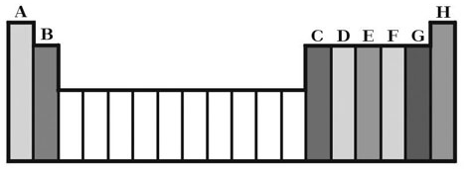
- Draw Lewis Dot Symbol for the following:
  - F
  - Ca

