Standard 1:
- What does VSEPR state? What determines the shape of a molecule?

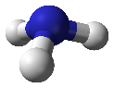
- What is the following shape? How many lone pairs and atoms bonded does it have? Why is there a downward angle to the molecule rather than being flat?

Standard 2:
- Describe a polar molecule including charge and electron distribution. How can a molecule with polar bonds be nonpolar?

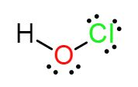
- Add polarity arrows/symbols to HOCl as needed. What shape is it? Is HOCl polar or nonpolar? Why is it polar or nonpolar?

Standard 3-4:
- Explain why intermolecular forces are not chemical bonds like intramolecular forces.

- Define the three intermolecular forces.

- Fill in the following chart
Type of IMF | Type of molecule that experiences this forces | Relative strength
Dispersion Forces
Dipole-Dipole
Hydrogen Bonding
- How does the type of force affect boiling points? Why does it have this effect?

- Identify the intermolecular forces for SeBr₂ or AsCl_{3.} Which substance would you expect to have a higher boiling point? Explain why.
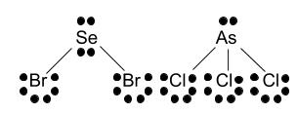

- How can solubility determine polarity? Explain why a polar and nonpolar molecule are not soluble using intermolecular forces.

- Answer the following questions based off the chart below:
Compound | Boiling point | Surface tension | Soluble with water
A | -5ºC | Low | No
B | 35ºC | Medium | No
C | 65ºC | High | Yes
  - Which substance(s) would likely be polar?

  - Which substance(s) would you expect to be soluble with oil?

  - Rank the substances from weakest to strongest intermolecular forces.

- What are three special properties of water? Explain why water has each property.

- Why is water polar?

Standard 1-3 Lewis Structure Practice
- Draw the Lewis structure for the following including polarity arrows/charges. Identify the shape, state if the molecule is polar or nonpolar, and the types of intermolecular forces.
- SiO₃²⁻

- ICN

- H₂O

